PRACTICAL: -9

Aim: - implement the grouping clauses group by, order by & having.

SQL> create table customers (cid int, cname varchar (50), country varchar (50));

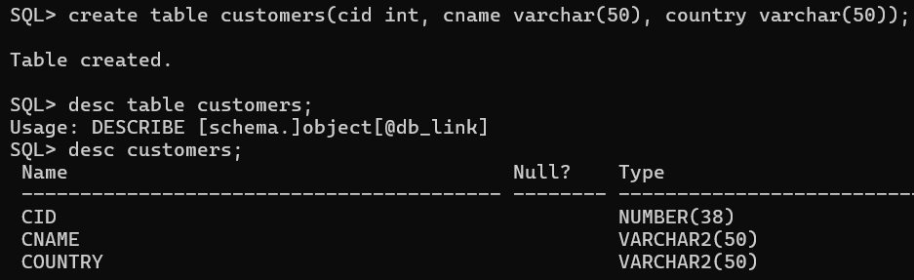

SQL> insert into customers values (1, 'rupa', 'India');

SQL> insert into customers values (2, 'rasi', 'India');

SQL> insert into customers values (3, 'Ramu', 'India');

SQL> insert into customers values (4, 'raja', 'Japan');

SQL> insert into customers values (5, 'Uma', 'Japan');

SQL> insert into customers values (6, 'Amit', 'Japan');

SQL> insert into customers values (7, 'Ravi', 'Japan');

SQL> insert into customers values (8, 'Upendra', 'USA');

SQL> insert into customers values (9, 'Bose', 'USA');

SQL> insert into customers values (10, 'Surya’, 'UK');

SQL> insert into customers values (11, 'Srihari', 'UK');

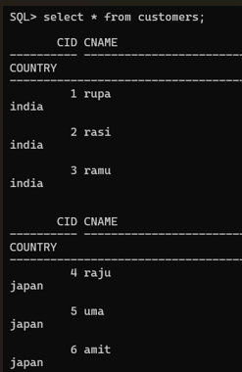 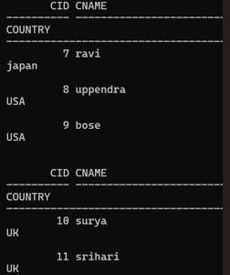

SQL> select count(cid), country from customers group by country;

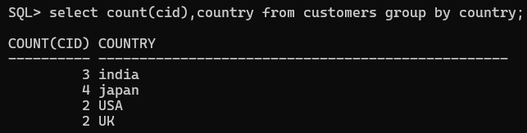

SQL> select count(cid), country from customers group by country HAVING COUNT (cid) <3;

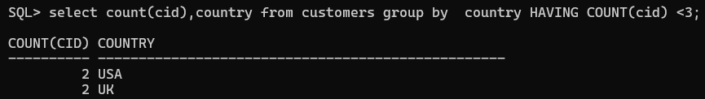

SQL> select count(cid), country from customers group by country HAVING COUNT(cid) >=2;

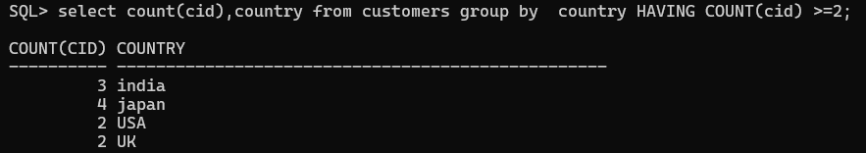

SQL> select cid, cname from customers order by cid asc;

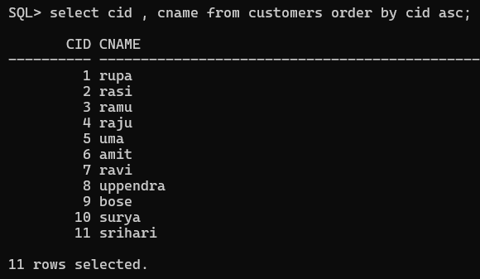

SQL> select cid, cname from customers order by cid desc;

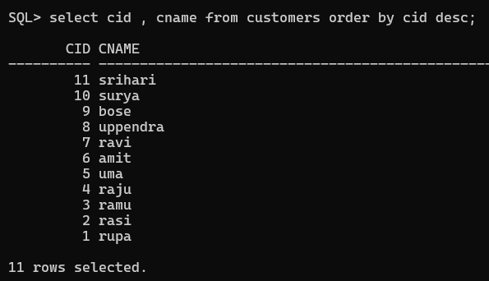

SQL> select cid, cname from customers order by cid asc, cname desc;

